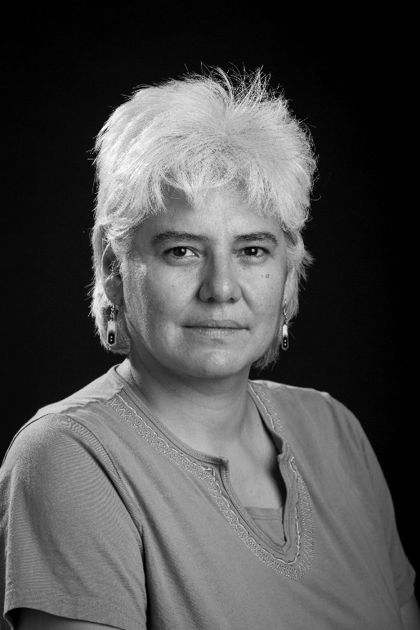
Alanis King
Alanis King is an Odawa playwright originally from the Wikwemikong Unceded Indian Reserve. Her playwrighting credits include Bury, Morning Becomes Electa, Wisakedjak (co-writer), Kawabin Elvis, Born Buffalo, Teacher, Kohkum’s Good Medicine Journey, Treaty Daze, Bye Bye Beneshe, Song of Hiawatha: An Anishnaabec Adaption, Order of Good Cheer, Gegwah, Lovechild, The Artshow, Heartdwellers, The Manitoulin Incident, Tommy Prince Story, and If Jesus Met Nanabush. 3 Plays was her first publication by Fifth House Publishers. Alanis is Past Artistic Director of Askiy Productions, Saskatchewan Native Theatre Company, Native Earth Performing Arts, Debajehmujig Theatre Group, Mazinaw Rocks Productions where she directed and dramaturged numerous works. She has been commissioned to write plays for the University of Wisconsin, the Centre for Indigenous Theatre, Shadowland Theaatre, Saskatchewan’s Awasis and the Wabano Centre for Aboriginal Health. Alanis is a Guest Lecturer, Drama Teacher and performing arts program developer to numerous educational institutions. She is the only female Aboriginal graduate of the prestigious National Theatre School of Canada.
Workshop

Renowned drama workshop leader, Alanis will focus on using drama to explore Indigenous social justice and equity issues by leading an Anishnaabe cross-cultural sharing of story, myth and expression common in the Aboriginal worldview. By bridging all backgrounds of participants, this workshop will celebrate and give voice to issues often ignored by the media. It is her intention to let participants create and to see how drama can be used to raise awareness and give voice to these issues.

